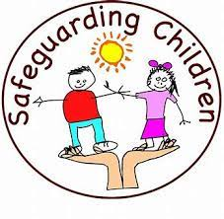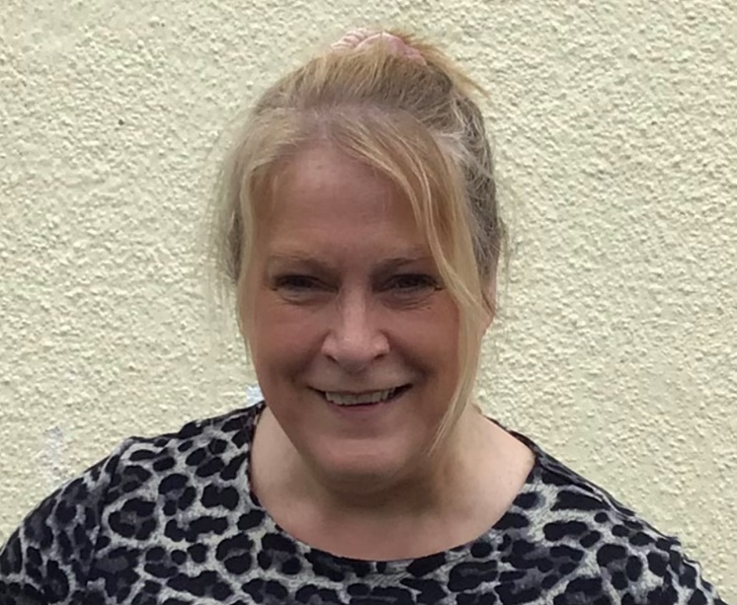

**YOU CAN COME AND TALK TO ME. I AM HERE TO LISTEN TOO.**

**COME AND TALK TO ME. I AM HERE TO LISTEN.**

**Mr. Lynch – Deputy Designated Teacher for Safeguarding**

**Miss McNulty – Designated Teacher for Safeguarding**

**if you are worried about something you can talk to an adult in school.**